Predicting Short-Term Stock Performance Based on ESG Ratings

A Comparative Analysis of Time Series Models

# Introduction

With an increasingly volatile climate, social instability and poor corporate governance, corporations are starting to embed sustainability into their practices, not just for the society, but also for their financial benefits. This project is focused on the relationship between firms’ environmental, social and governance (ESG) activities and financial performance. ESG ratings, which quantify companies’ sustainable efforts, for companies listed on S&P 500 were collected, along with their stock prices from 2020 to the present, as financial performance parameters.

The primary goal of this project is to develop predictive models for stock prices of the top 10% and bottom 10% of companies by ESG scores, and to compare their performance over time. Among the five time series forecasting models tested, Meta's Prophet emerged as the best performer. Predictions based on the model revealed that, surprisingly, companies with the lowest ESG scores (indicating higher ESG risks) exhibited higher stock returns compared to their higher ESG-scoring counterparts.

# Data Description

The ESG scores used in this project were sourced from Yahoo Finance, which aggregates data from Sustainalytics, an independent research and ratings firm specializing in corporate governance. Sustainalytics assesses over 16,000 companies globally and assigns ESG ratings based on their exposure to environmental, social, and governance risks, as well as the effectiveness of their risk management strategies.

Historically, Sustainalytics’ ESG ratings followed a system where higher scores reflected greater sustainability. However, since November 2019, the methodology shifted to emphasize the financial risk exposure companies face due to ESG factors. Under this new system, a lower ESG score now signifies better sustainability, as it indicates lower exposure to ESG-related risks.

This project uses the 2020 ESG scores, which reflects the updated rating methodology. The research specifically examines the ESG scores of companies listed on the S&P 500 index, which represents the largest publicly traded companies in the United States across diverse industries, offering a comprehensive view of the U.S. economy. Of the 503 companies included in the S&P 500 index, 493 companies had their ESG data provided by Sustainalytics.

For the financial performance component, stock price data for these 493 companies was collected from Yahoo Finance, which provides comprehensive financial data and news. The dataset includes adjusted closing prices, which account for corporate actions such as dividends and stock splits, spanning from January 1, 2020, to December 11, 2024.

# Models and Methods

The analysis began with the creation of a dataset that combined ESG risk scores for companies in the S&P 500 index. Alongside this, stock price data, specifically adjusted closing prices, were retrieved from Yahoo Finance for the same period, spanning January 1, 2020, to December 11, 2024. Of the 503 companies listed in the S&P 500, both ESG ratings and stock price data were available for 485 companies, forming the primary dataset for analysis.

To explore the relationship between ESG scores and financial performance, the dataset was further refined by categorizing companies into the top 10% of companies with the highest ESG scores and the bottom 10% of companies with the lowest ESG scores. Two separate financial datasets were then created, one for each group, allowing for a comparison of stock price trends and performance based on ESG risk levels.

For the purpose of building forecasting models, the stock prices of 48 companies in each group were aggregated by calculating the mean stock price within each group. The next step involved building and testing various time series forecasting models to predict stock prices for both high and low ESG risk groups. The dataset was divided into training and testing data, and since the forecasting model does not accept missing values in the dataset, they were dealt with forward fill, which takes the last value preceding the null value and fills it. A total of five forecasting models were selected for evaluation: naive forecasting, seasonality model, Holt-Winters’ model, auto-regression, and Meta’s Prophet. Naive forecasting serves as a baseline by assuming that future values will be equal to the most recent value; the seasonality model incorporates seasonal patterns; Holt-Winters’ model accounts for trends and seasonal components; auto-regression relies on past values to predict future values; and Meta’s Prophet is designed to handle time series data with strong seasonal effects and holidays.

The Root Mean Squared Error (RMSE) was employed as the performance metric to compare the accuracy of the different forecasting models in predicting stock prices on the test data. RMSE is a commonly used measure that quantifies the average magnitude of the error between predicted and actual values, with lower RMSE values indicating better model performance. The best model was then used to forecast stock prices for the next 30 days for both the top 10% and bottom 10% of companies, based on their ESG scores. The predicted returns for each group were then calculated, allowing for a direct comparison of the financial outcomes for companies with high versus low ESG risks.

# Results and Interpretation

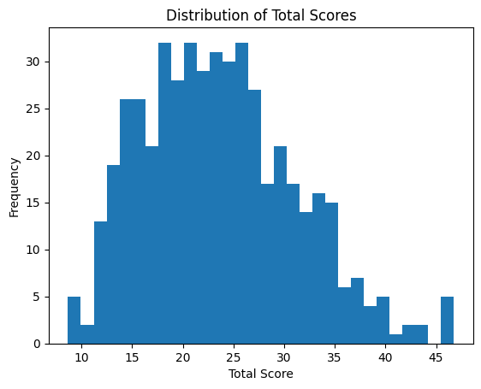

The ESG scores for companies listed on the S&P 500 index were found to be approximately normally distributed, though slightly skewed to the right, indicating that most companies had moderate ESG risk scores, with fewer companies exhibiting extremely high or low ESG scores. From this distribution, the top and bottom 10% of companies in terms of ESG ratings were identified. The ESG risk ratings for the top 10% of companies ranged from 8.67 to 14.28, signifying low ESG risk and a strong commitment to sustainability. In contrast, the ESG risk ratings for the bottom 10% of companies ranged from 34.05 to 46.76, indicating higher exposure to ESG risks.

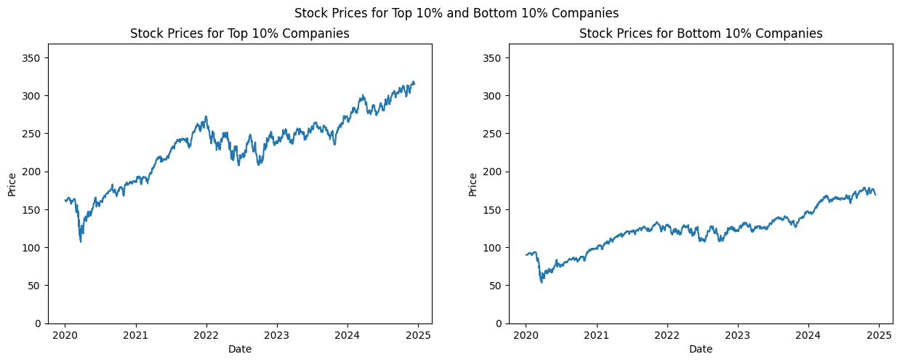

The stock price trends from the beginning of 2020 to the end of 2024 were then analyzed for both groups. Both the top 10% and bottom 10% of companies showed an upward trend in stock prices, though with slight fluctuations over time. The general trend for both groups exhibited a consistent increase from 2020 to 2022, followed by a mild drop or a slower rate of growth through the end of 2023, with a slight recovery or stabilization observed in early 2024. While the stock price trends for both groups followed a similar pattern, the top 10% of companies—those with lower ESG risk scores—demonstrated better financial performance in absolute terms, with higher stock prices compared to the bottom 10%.

## Naive Forecasting

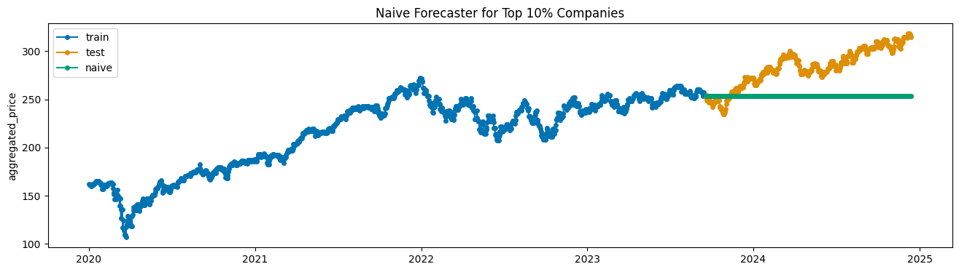

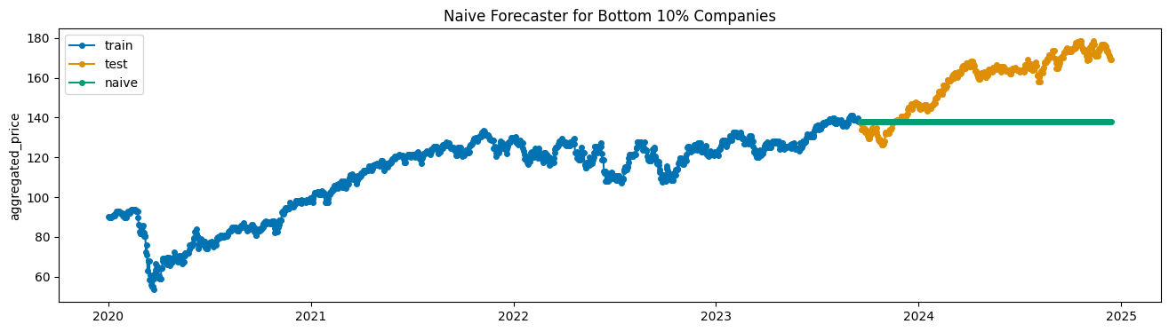

The naive forecasting model assumes that the future value of a time series will be equal to the most recent value in the training dataset. When applied to the stock price data for the top 10% and bottom 10% of companies based on ESG scores, the model’s performance was evaluated using RMSE. For the top 10% companies, the RMSE was 36.108, indicating a moderate level of prediction error for this group. In contrast, for the bottom 10% companies, the RMSE was 24.783, reflecting a lower level of error in predicting stock prices for companies with higher ESG risks. Although the Naive model provides a simple baseline, the differences in RMSE between the two groups suggest that the model's predictions were less accurate for companies with better ESG performance compared to those with higher ESG risks. This could be due to less volatile stock price trends among companies with higher ESG risks.

## Seasonality Model

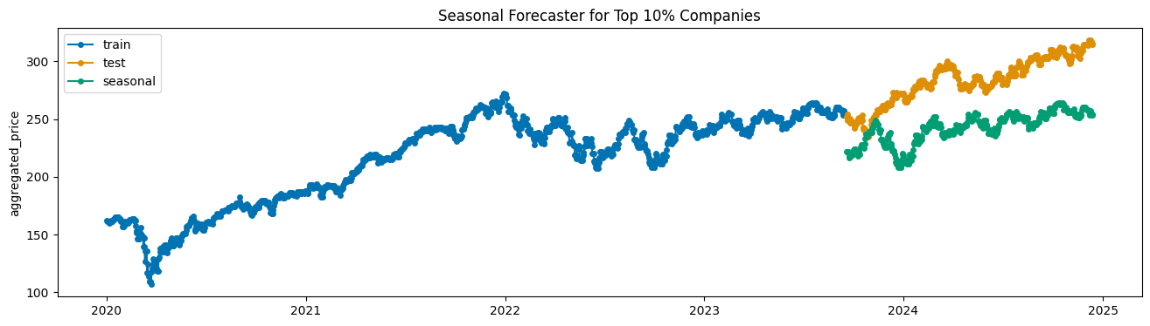

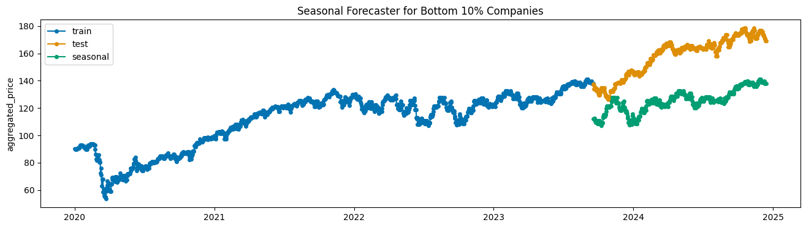

The seasonality model incorporates seasonal patterns in the data to make predictions. However, when applied to the stock price data for the top 10% and bottom 10% of companies based on ESG scores, the model's performance was less favorable than the baseline Naive forecasting model. For the top 10% of companies, the RMSE was 43.482, which was higher than the RMSE of 36.108 observed with the Naive model. Similarly, for the bottom 10% of companies, the RMSE was 34.173, which was also higher than the baseline RMSE of 24.783. Without taking into account the overall upward trend in stock prices observed from 2020 to 2024, the seasonality model did not outperform the simpler baseline approach in either group, suggesting that the seasonal effects alone may not have been sufficient to account for the variations in stock prices for both the top and bottom 10% of companies.

## Holt-Winters’ Model

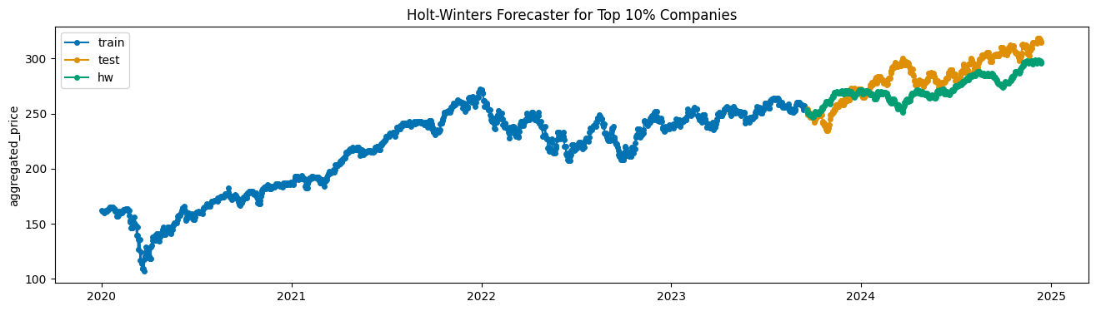

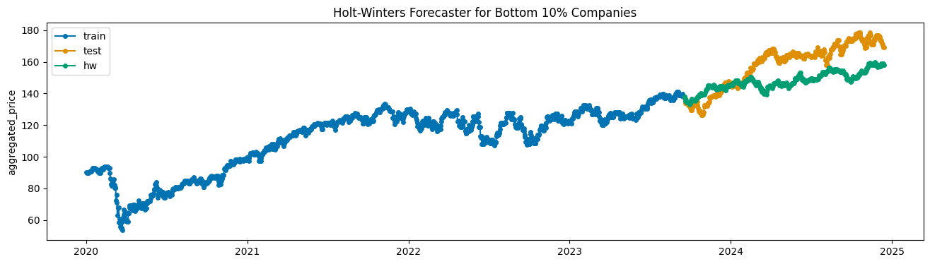

The Holt-Winters’ model is designed to handle both trends and seasonality in time series data. In this analysis, the additive seasonality version of the model was found to perform better than the multiplicative version, making it more suitable for the stock price data in this case.

When applied to the stock price data of the top 10% and bottom 10% of companies based on ESG scores, the Holt-Winters’ model outperformed the baseline Naive forecasting model. For the top 10% of companies, the RMSE was 17.662, significantly smaller than the baseline RMSE of 36.108, indicating a marked improvement in prediction accuracy. Similarly, for the bottom 10% of companies, the RMSE was 14.706, also smaller than the baseline RMSE of 24.783. These results demonstrate that the Holt-Winters’ model, by effectively capturing both the trend and seasonal components of the stock price data, provided more accurate predictions than the simpler Naive model for both high and low ESG risk groups.

## Auto-regression

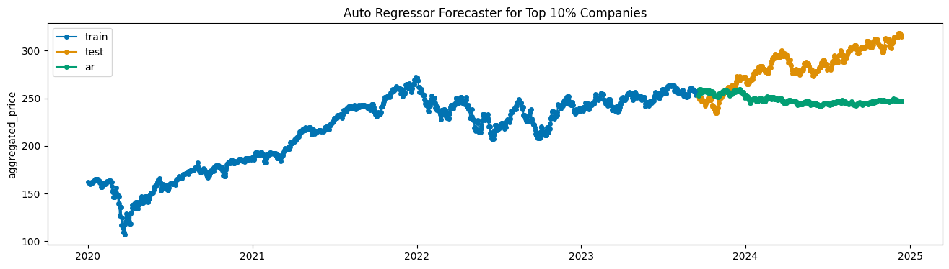

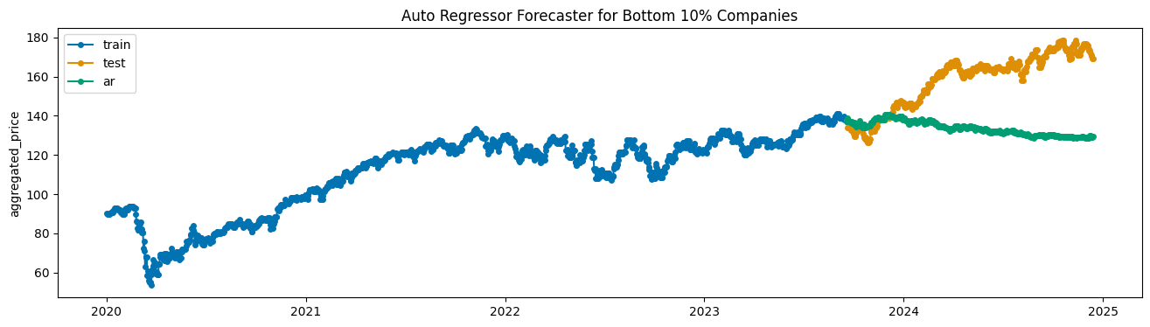

The auto-regression model (AR) forecasts future values based on the assumption that past values in the time series provide valuable information about future values. However, when applied to the stock price data, the auto-regression model underperformed compared to the baseline Naive forecasting model. For the top 10% of companies, the RMSE was 41.907, which was higher than the baseline RMSE of 36.108, indicating a less accurate prediction. Similarly, for the bottom 10% of companies, the RMSE was 29.934, also higher than the baseline RMSE of 24.783. These results suggest that the auto-regression model was not as effective at capturing the complexities of the stock market, particularly with the shift in market behavior in 2024. It is likely that the model depended too heavily on the past few data points from 2022 to 2023, a period where the stock prices were relatively stagnant or grew at a slower pace. This led the model to struggle in predicting the growth that started in 2024.

## Meta’s Prophet

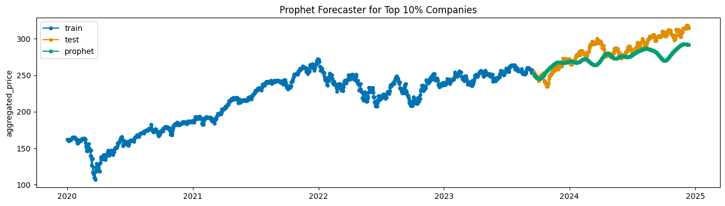

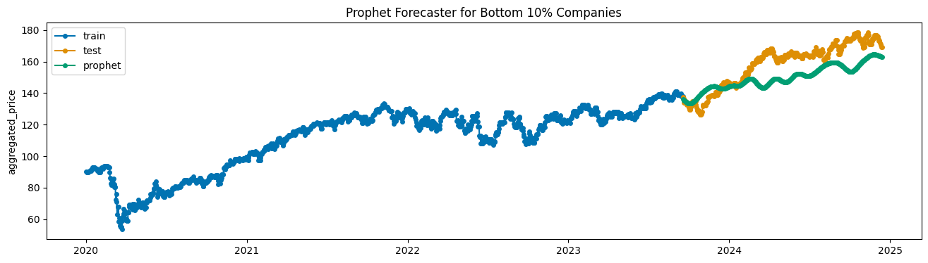

The Prophet model, developed by Meta, is designed to handle non-linear trends and is particularly well-suited for time series data with complex patterns, such as yearly, weekly, and daily seasonality, as well as holiday effects. When applied to the financial data of the top 10% and bottom 10% of companies based on ESG scores, the Prophet model outperformed all other models, including the baseline Naive forecasting model. For the top 10% of companies, the RMSE was 16.773, which was significantly lower than the baseline RMSE of 36.108 and even better than the RMSE of the Holt-Winters' model, which was 17.662. For the bottom 10% of companies, the Prophet model achieved the lowest RMSE of 12.022, outperforming the Holt-Winters' model which had an RMSE of 14.706. This superior performance underscores the effectiveness of the Prophet model in handling the underlying patterns of stock prices, better reflecting the complexity of the stock market.

## Prediction

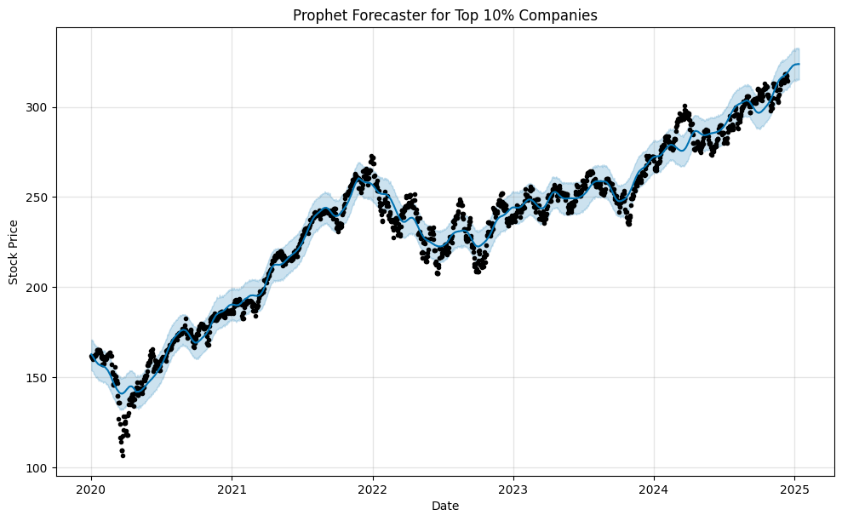

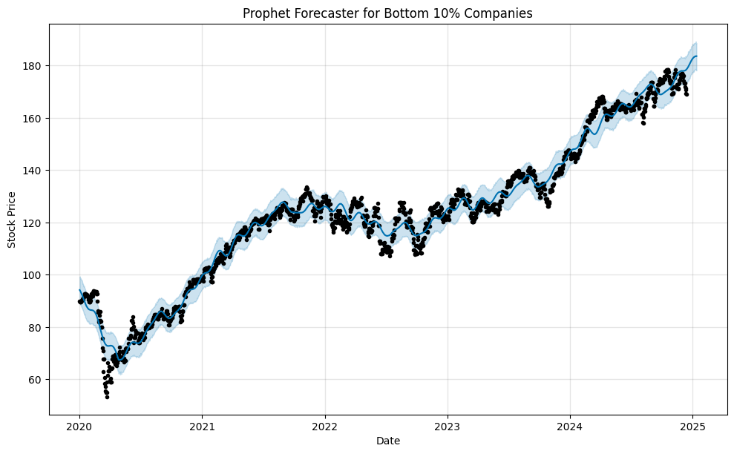

With the lowest RMSE, the Meta’s Prophet model was selected for predicting future stock prices for the top 10% and bottom 10% of companies based on their ESG ratings. With RMSE values of 16.773 for the top 10% and 12.022 for the bottom 10%, Prophet demonstrated strong predictive accuracy. To maintain the accuracy, the model was applied for short-term forecasts, specifically predicting stock prices 30 days into the future.

Based on these predictions, daily returns were calculated for each group, as well as the total predicted returns. Interestingly, the bottom 10% of companies, which had higher ESG risk ratings, showed a higher total predicted return of 2.94%, compared to the top 10% of companies, which had a predicted return of 1.56%. This result suggests that, at least in the short term, companies with lower ESG performance may experience higher returns, despite the higher ESG risks they carry. These findings highlight the potential trade-offs between ESG performance and financial returns, indicating that, in some cases, investors might prioritize short-term gains over sustainability factors.

# Conclusion and Next Steps

This analysis examined the relationship between Environmental, Social, and Governance (ESG) scores and stock prices for companies in the S&P 500, using time series forecasting models to predict future stock performance. The Prophet model, which performed the best in terms of forecasting accuracy, revealed that companies with lower ESG ratings predicted higher returns in the short term compared to those with higher ESG scores. The results suggest that, in the short term, investors may experience higher returns by investing in companies with lower ESG scores, although this does not negate the importance of ESG factors for long-term sustainability.

One limitation of this study is the relatively small sample size, as the analysis was based on data from just a few years and a subset of companies in the S&P 500 index. Another limitation is the use of a simple mean in order to aggregate stock prices, which may not have adequately accounted for the varying market capitalizations of the companies in the S&P 500. A weighted average could have provided a more representative analysis. Additionally, the focus on short-term predictions may not align with the typical investment horizon for sustainability-focused investors, who tend to prioritize long-term growth and stability over short-term returns.

Future research could explore the long-term effects of ESG on stock performance, using a more comprehensive dataset that spans a longer time frame. Additionally, incorporating a weighted aggregation method and expanding the scope to include other sustainability factors or broader market trends could yield more nuanced insights.

Despite these limitations, this study highlights the potential value of ESG metrics in predicting stock performance. As sustainability becomes an increasingly important factor for both investors and companies, future research will be essential in understanding its long-term implications for financial markets.